**SPRING-42 – FLYWAY DATABASE**

Flyway DB is used as version control of database changes. Suppose we make changes in any table like adding column or modifying field or inserting data, we can keep track of these changes with the help of flyways as it keeps this info in its flyway history table.

Dependency:

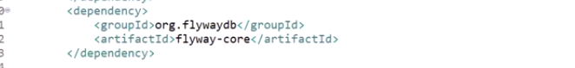

Properties file:

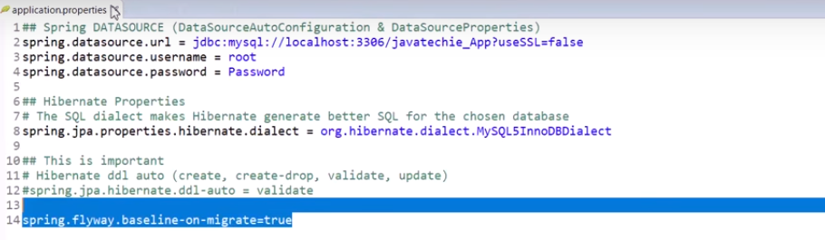

DB Folder created automatically:



We need to place our DB scripts under this folder:

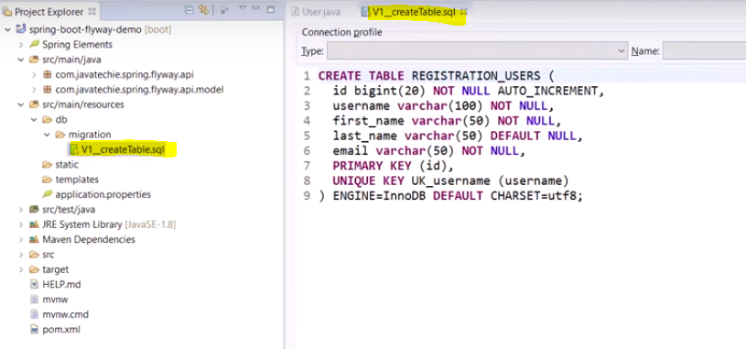

Logs:



Now in DB 1 extra table would be generated called ‘flyway_schema_history’:

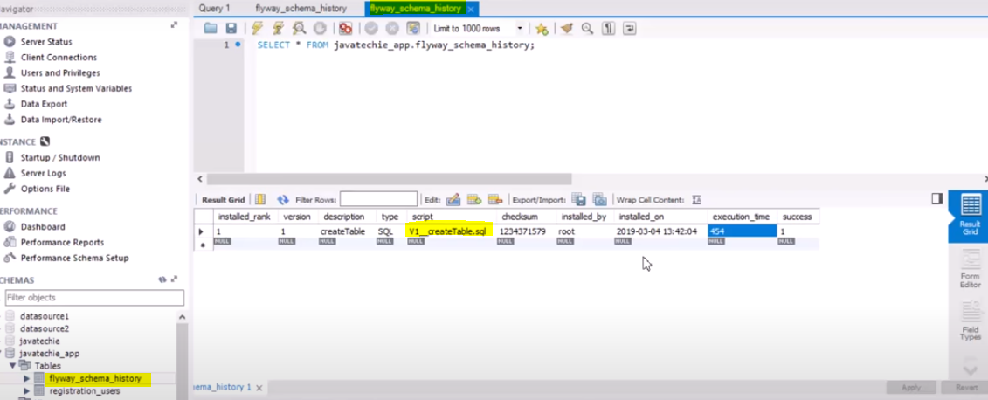

Now if we do more changes:

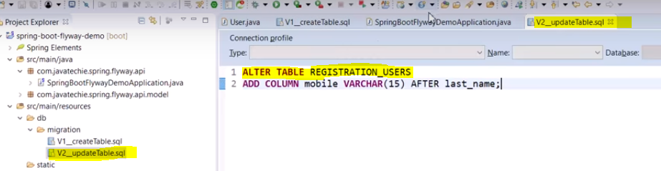

Logs:



DB:

